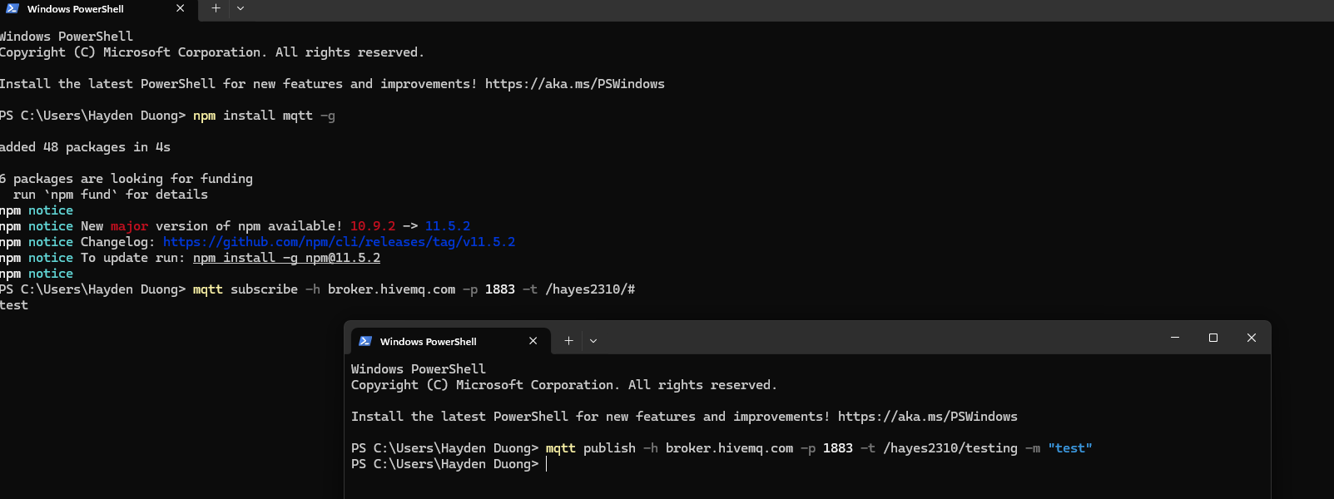
Picture 1 – Result gained from step 5 & 6.
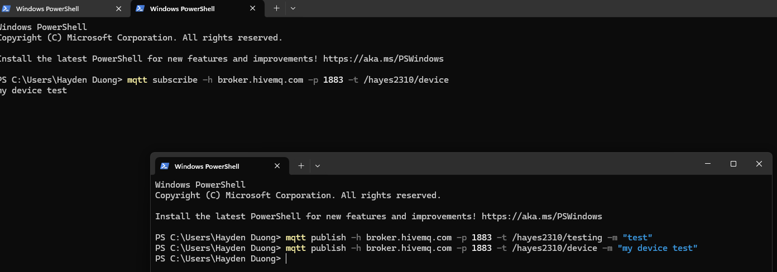
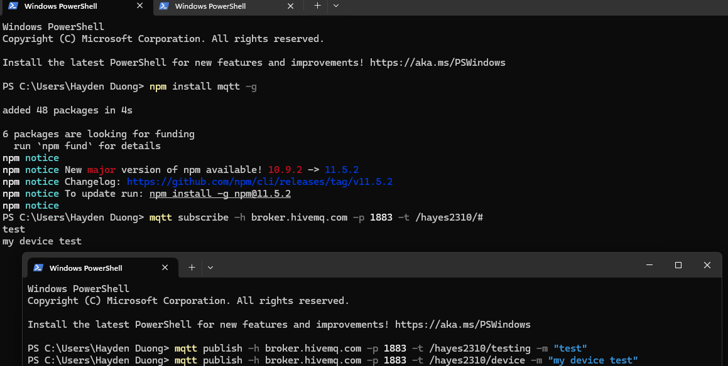
Picture 2 – Results gained from step 8 & 9 (both subscribers received “my device test”).
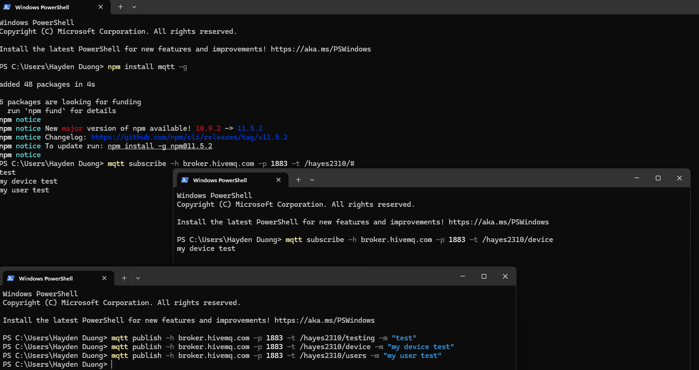
Picture 3 – Result gained from step 10 (only one of the subscribers is received the message).
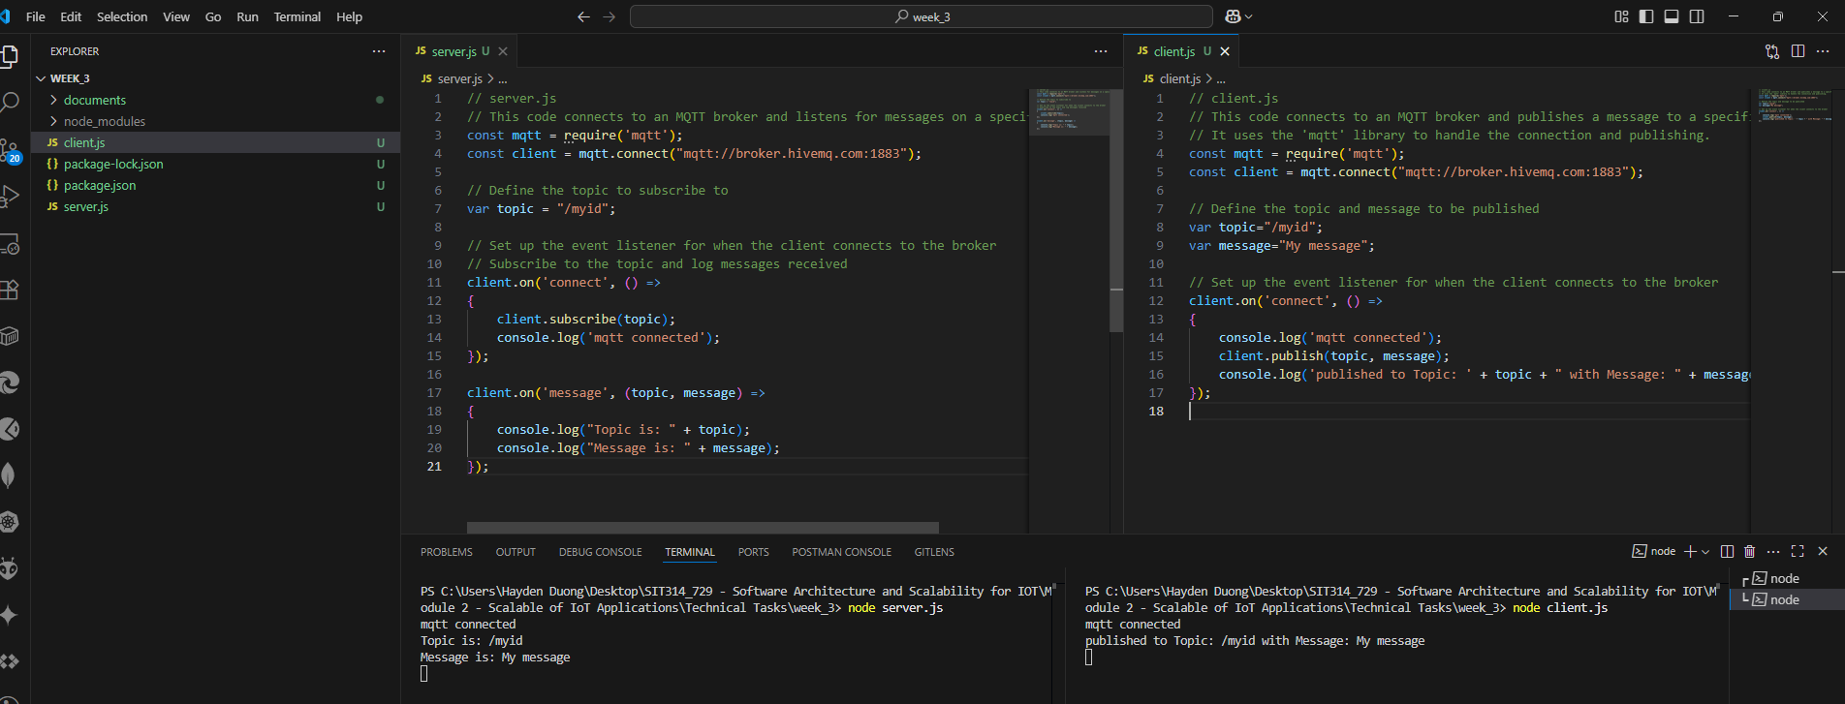
Picture 4 – Results gained from “Writing simple programs that use MQTT”.

